

**MARKING GUIDE - 2023**

P250/1

**GEOGRAPHY**

# *00 - Totally irrelevant answer*

# *01 – 08 - Rudimentary answers i.e. a few undeveloped and*

# *scattered facts.*

# *09 -11 - ‘O’ level answer*

# *12 – 14 - Basic ‘A’ level answer*

# *15 – 17 - A good answer*

# *18 – 20 - A very good answer*

# *21 – 25 - An excellent / outstanding answer*

# *SECTION A*

*Questions* ***1*** *and* ***2*** *are* ***compulsory***

***COMPULSORY MAPWORK QUESTION:***

1. *Study the East Africa 1:50,000 (UGANDA),* ***BUDADIRI*** *Map extract; part of sheet 54/4 (Kenya Sheet, 74W/4, Series Y732; Edition 2-U.S.D. and answer the following questions.*
   1. *(i) State the grid reference of the bridge across Sanoli River. (01 mark)*

*4 4 6 2 8 6*

*(5) (6)*

*(ii) Name the feature found at grid reference 476252. (01 mark)*

*Man made feature at grid reference 476252 is a secondary trigonometrical station at Mamugabwe.*

* 1. *(i) Measure and state the bearing of Bukalasi Trigonometrical station (grid*

*reference 569132) from the bridge at Bukiga (grid reference 494164).*

*(01 mark)*

*The bearing is 113o (111o – 115o)*

*(ii) Calculate the ground area in kilometres squared of Buyobo sub-county*

*shown on the map extract. (02 marks)*

*Area = Full sq. + $\frac{Half sq.}{2}$*

*= $39 + \frac{19}{2}$ M -*

*= 39 + 9.5 = 48.5km2*

*= A(01mark)*

* 1. *(i)* ***Draw a cross section of the area along Northing 30 between Eastings***

***42*** *and 50 and on it mark and label the following:*

* *Gently sloping areas*
* *Buyola hill*
* *Broad River valley*
* *All-weather road*
* *Sanoli River*
* *Nakiwondwe forest reserve (10 marks)*

*On graph paper*

*(ii)* ***Explain why it is important to exaggerate the height scale of a cross***

***sectional drawing.*** *(02 marks)*

*By exaggerating the height or vertical scale, the differences in elevation are magnified making it easier for one to perceive the differences in relief. It is therefore important for clarity and emphasis especially where features would not be noticeable with a true – to scale vertical axis.*

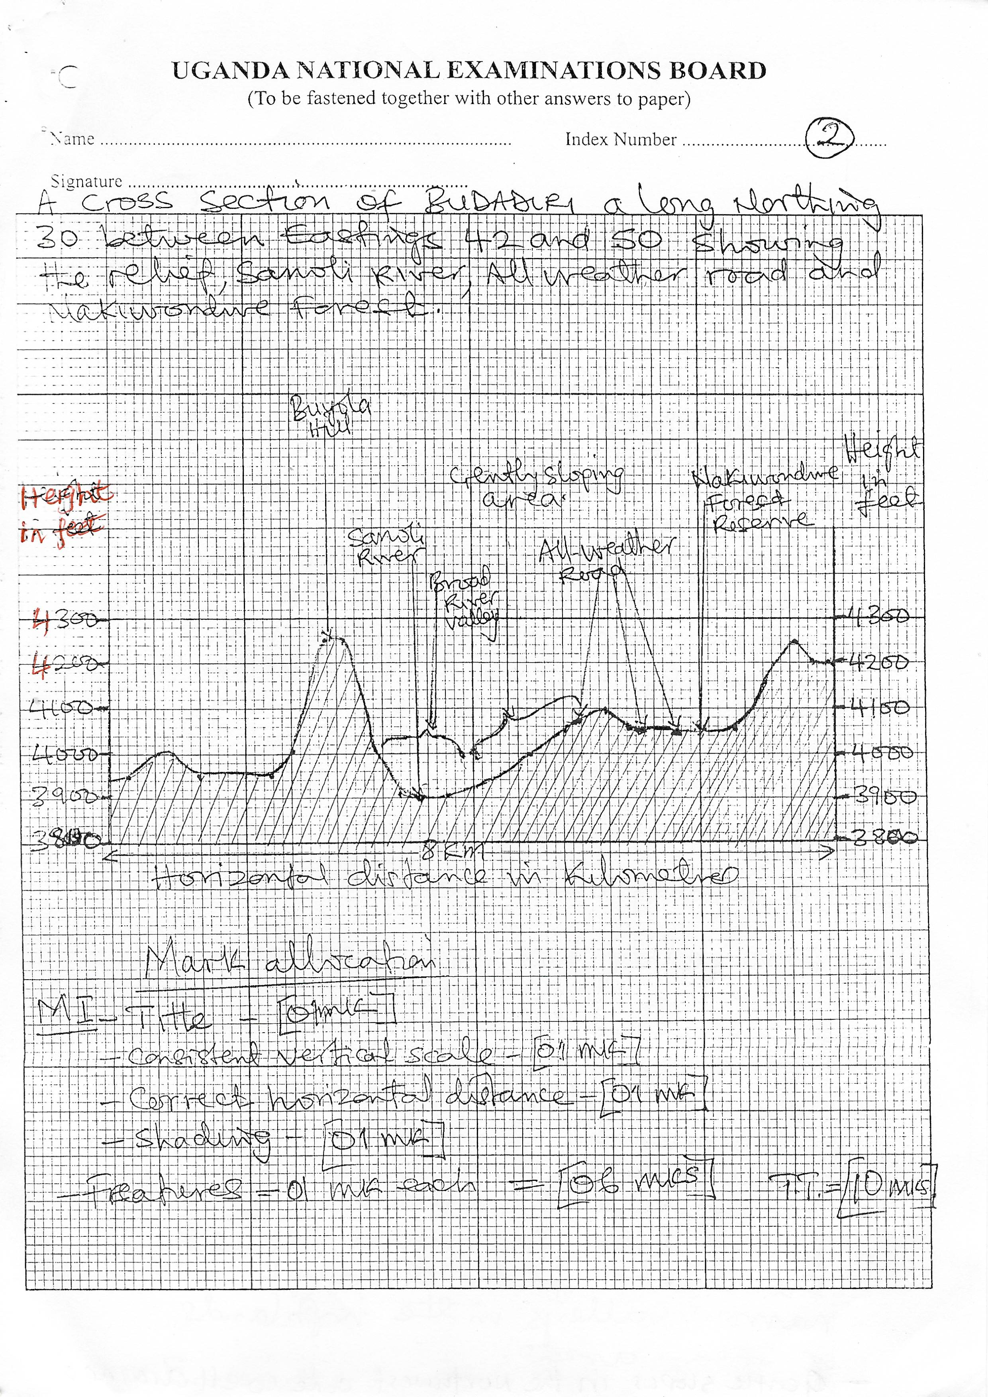

* 1. ***With evidence from the map extract, identify the economic activities carried out in the area.*** *(04 marks)*
* *Coffee growing / cultivation – evidenced by coffee by coffee stores spread throughout in the area e.g. at Buyobo, Bumasifwa, Buteza, Bukimema, Bulucheke etc*
* *Transformation – evidenced by the roads in the area e.g. the Mbale – Budadiri road, the Bukigai ring road etc*
* *Forestry evidenced by Mt. Elgon forest, Bukigai Forest reserve, Nakiwondwe Forest reserve*
* *Tourism evidenced by the rest house at Bumasifwa in the north; Bulucheke R.H*
* *Trade evidenced by the trading centres e.g. Budadiri trading centre, roads and coffee stores.*

*Any 4 x 1 = 4 marks*

*NB: Activity must have evidence.*

* 1. ***Explain how relief has influenced the nature of drainage in the area shown on the map extract.*** *(04 marks)*
* *Rivers tend to flow from the higher altitude areas*
* *Uplands / highlands / ridges like Bunambatsu, Bundagala, Bumagabura etc form watersheds / are sources of rivers*
* *Rivers like manafwa, sakusaku, sume etc flow through narrow valleys in the highlands or steep areas*
* *Gentle slopes in the northwest are well drained*
* *Steep slopes of ridges e.g. Bugobero, Namugabwe etc are well drained*
* *Some ridges like Bukigai form radial and annular patterns*
* *Some rivers like Sanoli flow through broad valleys in the gently sloping area of the North West.*
* *On the gentle slopes dendritic drainage pattern has developed e.g. around Buyobo and Buteza in the North West*

*Any 4 x 1 = 4 marks*

*Total = 25 marks*

# *COMPULSORY QUESTION:*

# *PHOTOGRAPHIC INTERPRETATION*

1. *Study the photograph provided below and answer the questions that follow:*

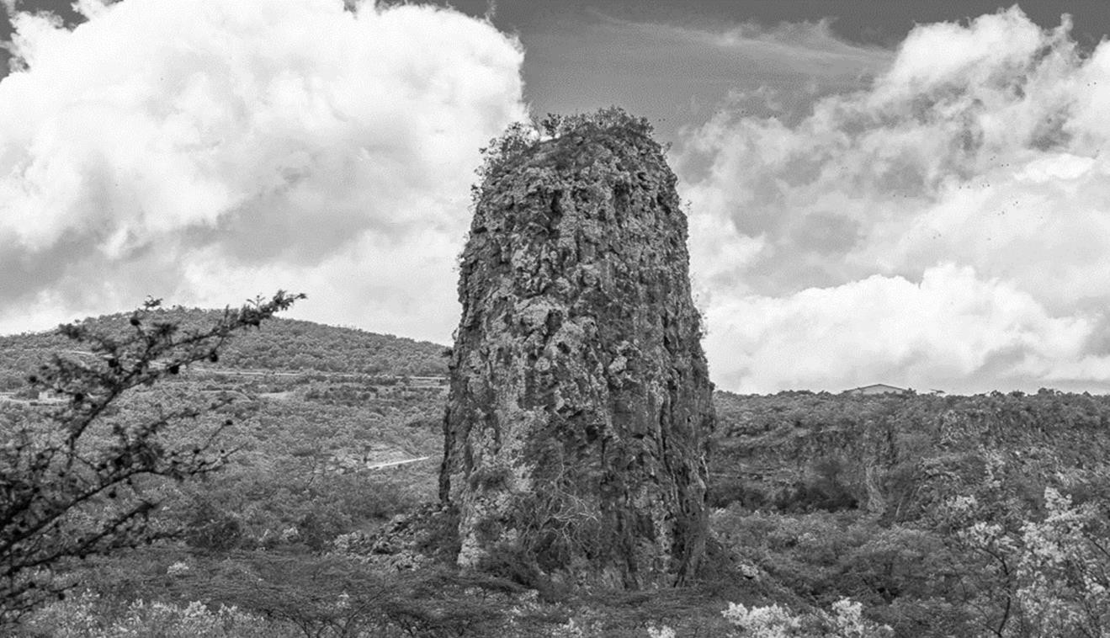

* 1. *Draw a landscape sketch of the area shown on the photograph and on it mark and label the:*

1. *Landform features*
   * + *Volcanic plug / inselburg*
     + *Hill*
     + *Gentle slopes*
     + *Cliff / very step slope*
     + *Talus slope / scree slope*

1. *Main vegetation type*

* *Thorn bush / bush land / scrub*
* *Dry savannah / semi desert / vegetation*

1. ***Two*** *types of human features*
   * + *Roads*
     + *Buildings / structure / house / settlement*

1. *Type of clouds above the horizon (09 marks)*
   * + *Clouds – stratus / cumulus clouds / nimbus – stratus*

***A landscape sketch of the area in the photograph showing landform features, vegetation type, human features and clouds.***

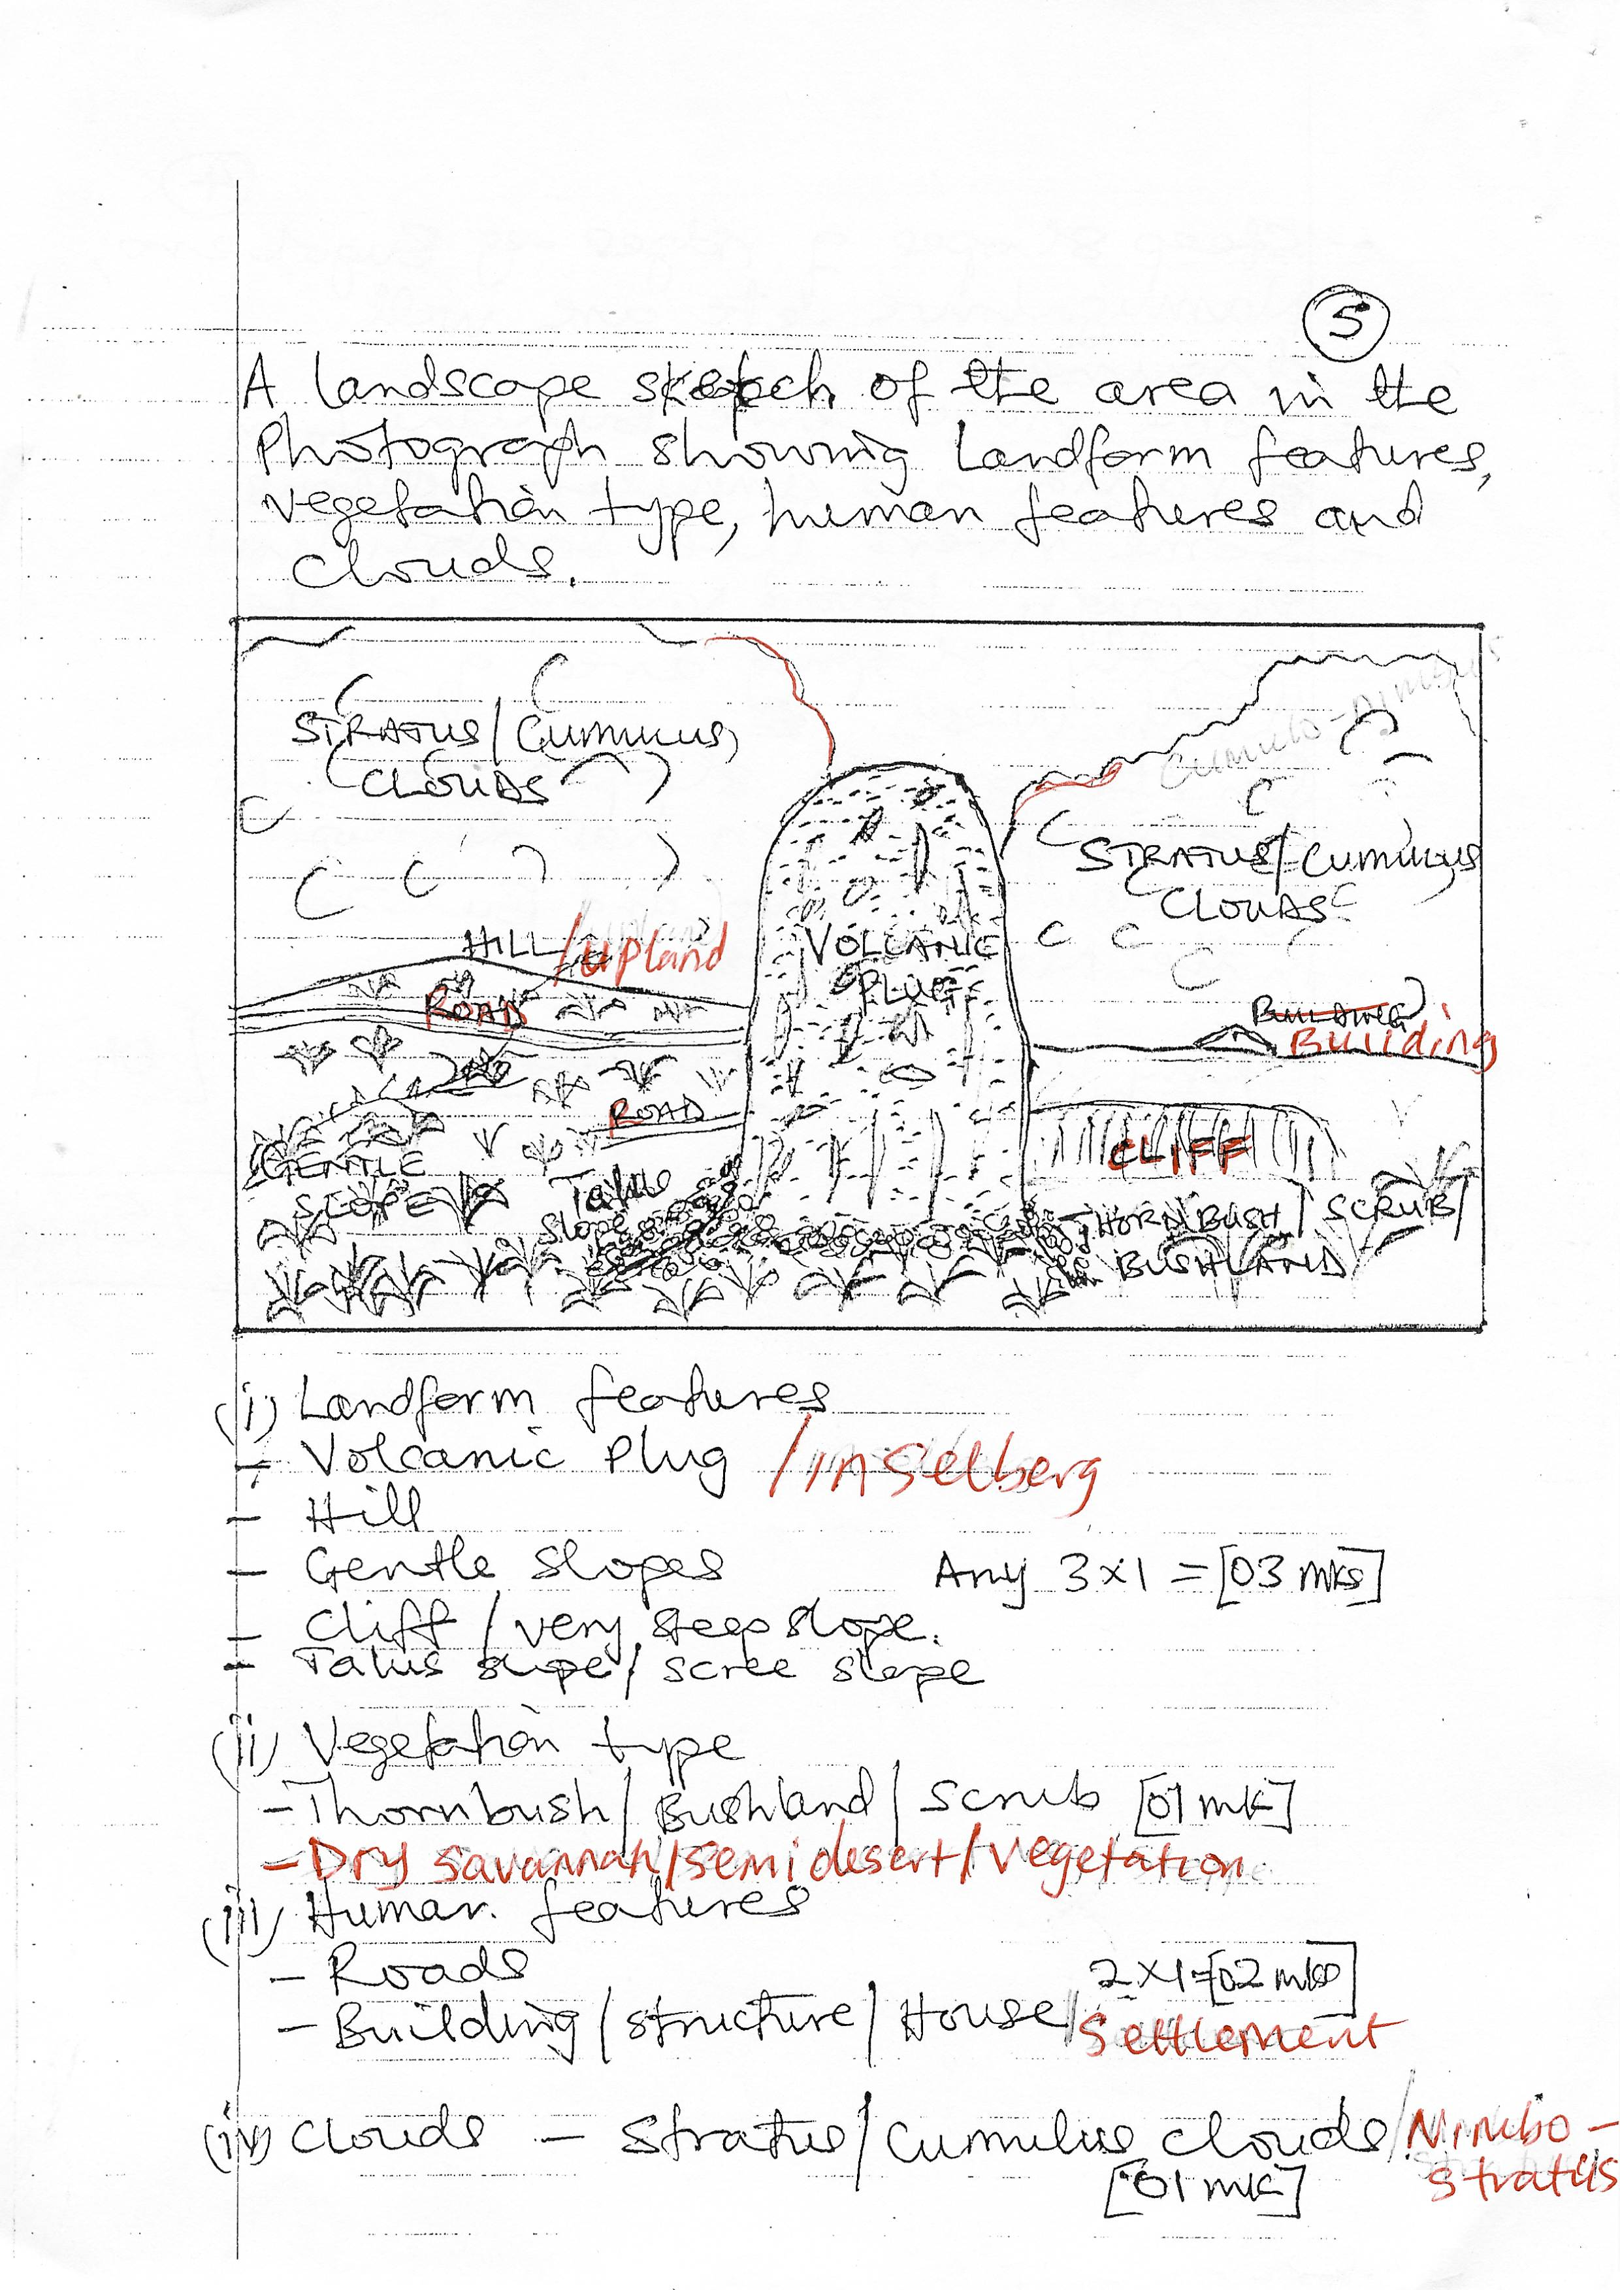

*Marginal information*

* *Title / heading (01 mark*
* *Frame (01 mark)*
* *Key / labelling (01 mark)* 
  1. *Account for the formation of the prominent landform feature in the middle foreground of the photograph. (04 marks)*

*The prominent land form feature is a volcanic plug or plug dome*

* *Is a massive cylindrical formation or rock pillar of solidified acidic viscous lava*
* *Formed when acidic / viscous lava is extruded and solidifies at the point of eruption*
* *For example, the Tororo rock, central tower, Fischers tower, hyrax tower etc*

***Considerations***

* *Identification of feature (01 mark)*
* *Description / characteristics (01 mark)*
* *Illustration / diagram (01 mark)*
* *Example (01 mark)* 
  1. *(i)* ***Explain how the clouds shown in the photograph were formed.***

*(04 marks)*

*The clouds are an accumulation of tiny particles of water or ice crystals floating in the sky. Water vapour from evaporation or transpiration rises with air , is adiabatically cooled and condenses to form tiny water droplets.*

*(ii)* ***Examine the significance of the cloud cover to the weather and climatic***

***conditions of the area shown in the photograph.*** *(06 marks)*

* *Prevents sun rays from directly striking the surface thus reducing on the amount of solar radiation received.*
* *May lead to the formation of rainfall in the area*
* *May result into gloomy days with less hours of sunshine*
* *They obstruct visibility of the air i.e. reduce on visibility*
* *They trap outgoing terrestrial radiation resulting into warmer temperatrues*
* *They emit electric charges that lead to the occurrence of static electricity like lightning during thunder storms*
* *The clouds or their nature help meteorologists predict the type of weather condition likely to occur i.e. help in weather forecasting.*

*Any 6 x 1 = 6 marks*

* 1. *Giving reasons for your answer, suggest an area in East Africa where this photograph could have been taken. (02 marks)*

*The photograph could have been taken in the following areas;*

* *Naivasha (Hell’s gate national park)*
* *Around the Katwe crater*
* *In Tororo*

*Reason : - Presence a volcanic. Plugs in these areas (01 mark)*

# *SECTION B:*

*Answer* ***one*** *question from this section*

1. *(a) Identify the sources of heat in the earth’s interior that may trigger off*

*tectonic processes. (08 marks)*

*Sources of heat in the earth’s interior*

* *Stored heat from the time of the formation of the earth over 4.5 billion years ago i.e. primordial heat*
* *Radioactivity of elements like uranium, thorium, potassium i.e. the radioactive decay of isotopes that releases energy in form of heat i.e. radiogenic heat*
* *Geochemical reactions that involve interaction of various elements and compounds within the earths rocks, releasing energy in form of heat. These are also referred to as exothermic reactions*
* *Gravitational forces in the earths interior causing moving matter to heat up. In addition the settling and compression of denser materials towards the earth’s core generates heat energy known as gravitational heat / frictional heat*

*4 x 2 = 8 marks*

*(b) Relate the nature of volcanic material ejected from the interior to*

*the resultant extrusive landforms in East Africa. (15 marks)*

*Relate the nature of volcanic material ejected from the interior to the resultant extrusive features:-*

* *Volcanism is the process responsible for the upwarp movement of magma through the crust on to the earths surface. It is characterized by volcanic eruptions and the extrusive land forms result from the solidification of the lava after cooling.*
* *The nature of volcanic material ejected from the interior includes*

1. *Magma - acidic, basic and intermediate*
2. *Pyrodastrics – volcanic ash, dust lava bombs and cinder*
3. *Volcanic gases (gas eruptions)*

*These can be categorized as liquid (molten rock), gaseous and solid.*

*Magma / lava is the dominant material from the interior. The nature of magma influences the nature of eruption and ejection of the accompanying material and consequently the development of the land form feature.*

*The nature of volcanic material ejected can be related to the resultant extrusive landforms as follows:*

*Acidic lava . Lava with high silica content. It is viscious and cools rapidly and is characterized by violent and explosive eruptions*

* *Leads to formation of lava cones on cooling and solidification*
* *Leads to formation and composite cones (strato volcanoes) characterized by lava and ash, subsidiary cones may also develop e.g. Mt. Elgon, Muhavura, Kilimanjaro, Kenya, Meru, Suswa, Lengoietc*
* *Formation of volcanic plugs / plug domes / spire volcano i.e. when viscous acidic lava solidifies soon after extrusion or partially within the vent e.g. Tororo rock, lenana and Batiam plugs on Mt. Kenya; central tower, Hyrax tower,Fischer’s tower in Naivasha.*

*Intermediate lava*

* *Lava with moderate silica content after eruption, cooling and solidification may lead to the formation of the following:-*
* *Cumulo domes / memelons i.e. rounded volcanoes without a crater is formed when surface lava hardens (solidifies) when the interior is still molten. Further, upwelling of magma than forces the hardened layer outward e.g. Mt. Ntumbi National park in Kenya.*
* *Tholoids – These are cumulo dome like features that have formed in a crater or caldera after an eruption e.g. on Mt. Rungwe in Tanzania; also cassava volcano in Kisoro.*

*Basic lava*

* *Is lava with less content silica content and therefore fluid / runny. Eruption is when lava flows from several vents. Eruptions are normally quiet. The cooling and solidification may result into the following:*
* *Basalt domes / shield volcanoes / basic lava domes i.e. when lava spreads over a wider area e.g. Mt. Marsabit, Mt. Tukuyu in the Rungwe range, Mt. Nyamulagirra.*
* *Lava plateaus; due to fissure eruptions the lava spreads out to form a plateau e.g. the yatta plateau and the Laikisia plateau. Also the Kisoro plains.*

*Pyroclastic material*

* *This involves the erruptions of burnt out rocks and sash or dust and rock fragments (lapilli) deposition of such material may lead to the formation of;*
* *Ash and cinder cones scoria cones) e.g. Mt. Likaiyu near lake Turkana and the several ash and cinder cones in Kisoro.*

*Gaseous material*

* *Involves gas explosions / eruptions through crystalline basement rocks and this has led to the formation of the following; explosion craters / ring craters / the rock waste piled around the point of eruption forms explosion craters e.g. several ring cratrs are found in the Queen Elizabeth national park e.g. the Katwe crater, Kikorongo, Nyamunuka, Munyanyange, Kasenyi, Munyanpakaetc*

*NB: How the nature of material ejected relates to the landform should be clearly indicated*

***Impressional marking = (17 marks)***

1. *Examine the factors that have influenced the formation of drainage patterns*

*in East Africa. (10 marks)*

*Drainage pattern first ought to be defined as the structures and physical lay out of a river and its tributaries. The types of drainage patterns include the following:-*

* *Dendritic drainage pattern*
* *Radial drainage pattern*
* *Trellis drainage pattern*
* *Centripetal drainage*
* *Parallel drainage*
* *Rectangular drainage*
* *Barbed / braided drainage*
* *Pirinate drainage*
* *Annular drainage*
* *Antecedent drainage*
* *Super imposed drainage*

*NB: The drainage patterns may be either accordant or discondant patterns*

*The formation of drainage patterns in East Africa is influenced by a combination of geological, tectonic, climatic and topographical factors which include the following;*

* *Rock structure / nature of rocks*
* *Homologeneous rocks may result into the formation of dendritic and radial patterns.*
* *Heterogenous rocks may result into parallel annular and trellised drainage pattern*
* *Well jointed rock may also lead to trellised and rectilinear patterns*
* *Relief / topography / nature of slope;*
* *Highlands or domes favour the development of radial and annular patterns e.g. on Mt. Muhavura, Mt.Elgon, Kilimanjaro etc*
* *Gentle slopes have favoured development of dendritic patterns*
* *Basin or depressions encourage the formation of centripetal patterns*
* *Existence of hills separated by wide valleys lead to the development of trellised pattern*
* *Tectonic processes or tectonism.*
* *Warping leads to the development of centripetal pattern e.g. down warped depression of central east Africa led to the formation of Lake Victoria with a centri petal pattern.*
* *Faulting has led to the development of faultlines that has favoured the formation of trellised and parallel patterns*
* *Faulting has also led to the development of antecedent drainage patern e.g. pattern on the river Ruaha in Tanzania*
* *Volcanicity has led to the formation of volcanic cones that exhibit a radual drainage pattern e.g. or Mt. Kilimanjaro, Elgon, Muhavuraetc*
* *Nature of climate.*
* *Drainage patterns tend to develop as a result of heavy and reliable rainfall ina catchment area. This is because ample rainfall is rewuired for the development of main streams and continuous flow of their tributaries e.g. in the highland areas of East Africa.*
* *River capture. This may result into trellised pattern, dendritic pattern or even barbed pattern e.g. when lower Tiva captured the waters of upper Tiva which was a farmer tributaries of R. Galana, a dendritic pattern was formed.*
* *Human activities through construction of dams and canals leading to parallel patterns*

*Impresional marking = 25 marks*

1. ***How Does Charles Darwin’s theory of subsidence explain the formation***

***of coral reefs along the East African coast?*** *(25 marks)*

* *Coral reefs first need to be defined as ridges or rock platforms formed from accumulated depsits of skeletons of coral polyps. Coral polyps are lime secreting marine organisms in coastal areas. The continental shelf provides a base for the deposition and accumulation of the skeletons of dead coral polyps*
* *The types of coral reefs need to be identified and described or illustrated. These include;*
* *Fringing reefs – are separated from the mainland by narrow and shallow lagoons*
* *Barrier reefs; lie far off the coast and are separated from the mainland by wide and deep lagoons*
* *A tolls – are circular ridges of coral rock platforms enclosing a lagoon*
* *Conditions favouring the development of coral reefs need to be identified and these include the following;*
* *Warm waters of about 20o – 3o0C*
* *Salty / saline water conditions*
* *Shallow water is not more than 60 metres dep*
* *Clear / clean and well oxygenated waters for plankton growth*
* *Submerged (Water) conditions*
* *Variation in water levels i.e. high and low tides to allow death and accumulation of coral shells*
* *Calm waters i.e. absence of strong water currents*
* *Presence of a continental shelf and oceanic ridges or islands*
* *The process for the formation or development of coral rocks and consequent development of coral reefs then needs to be outlined, to include the following:-*
* *Deposition / accumulation of skeletons of coral polyps*
* *Accretion – up building of deposited material due to accumulation*
* *Compression / compaction and consolidation of the coral material under its own weight*
* *Cementation / lithification of the material with the help of calcareous algae and echinoderms*
* *Sedimentation and stratification of the rocks*
* *Darwins’s theory of subsidence then needs to be explained in relation to the foramatio of coral reefs. i.e. how the coral reefs were formed according to Darwin.*

*According to Darwin Barrier reefs and A tolls developed from Fringing reefs that grow around the coast of s subsiding volcanic island.*

***Darwin contended the following****:-*

* *That there existed the presence of a volcaning island on the sea floor.*
* *Polyps colonized the edges of the volcano later forming a fringing reef*
* *The volcanic island slowly subsided as a result of isostatic re-adjustemnts that followed eruptions*
* *Such subsidence increased the depth of water beyond the level at which coral polyps can survive. Coral polyps subsequently died while some tried to grow to keep pace with the changes in depth as the island subsided, the corals contined to grow upwards keeping pace with the rising sea level. In addition, coral reefs grew more vigorously on the sea ward side (i.e. growing upwards and outwards) leading to a deeper lagoon and eventual formation of a barrier reef*
* *Continued subsidence ultimately resulted into complete submergence of the island leaving the barrier reef as a ring of coral reefs known as an a toll.*

***Diagram to illustrate Darwin’s theory of coral reef formation***

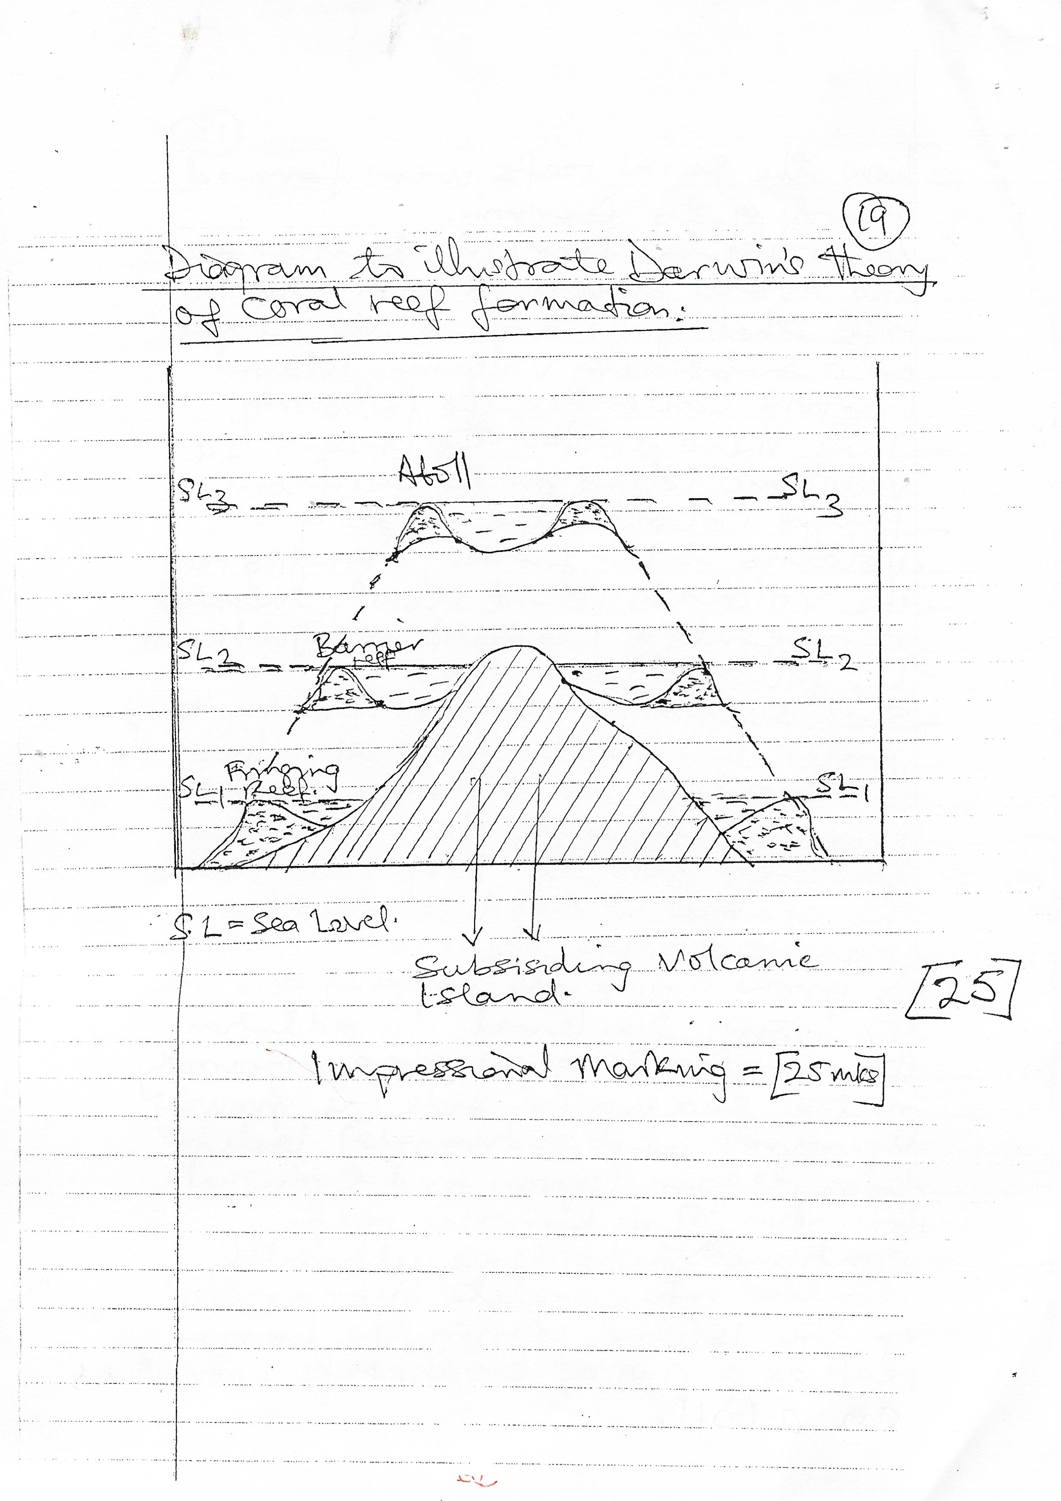

***Impressional marking = (25 marks)***

# *SECTION C:*

*Answer* ***one*** *question from this section*

1. *(a)* ***Explain how relative humidity is manually measured at a weather station.***

*(15 marks)*

*Relative humidity is the measure of how much moisture / vapour is in the air compared to the maximum amount the air can hold at a given temperature and pressure*

* *Relative humidity is measured using an instrument called a hygrometer / wet and dry bulb themomeer / sling psychrometer. This instrument consists of 2 ordinary thermometers; the bulb of one is covered with Muslin / wick (piece of linenecllth) which dips into a container of (distilled) water. This is called the wet bulb thermometer. The second thermometer does not dip into water and is thus the dry bulb thermometer*
* *When there is a lot of moisture in the atmosphere (high humidity) there is very little evaporation from the Muslin. Therefore the wet bulb will not be cooled and the wet bulb will not be cooled and the temperature recorded will be high. When there is dry atmosphere (low humidity) a lot of evaporation takes place from the muslins which process cools the bulb and results into a lower temperature recorded by the wet bulb thermometer compared to the dry bulb thermometers*
* *For easy interpretation the following guidelines are followed to determine the humidity levels*

1. *A large difference the two readings implies there is low humidity*
2. *A small difference in the readings or recordings implies there is high humidity*
3. *The same readings on the two thermometers implies that air is saturated*

* *Relative humidity can then be found by subtracting the temperature on the wet bulb thermometer from that on the dry bulb thermometer. Then one refers to the relative humidity chart / table or the psychrometric chart*
* *The value of the difference is matched with the ambient air temperature to determine the relative humidity.*

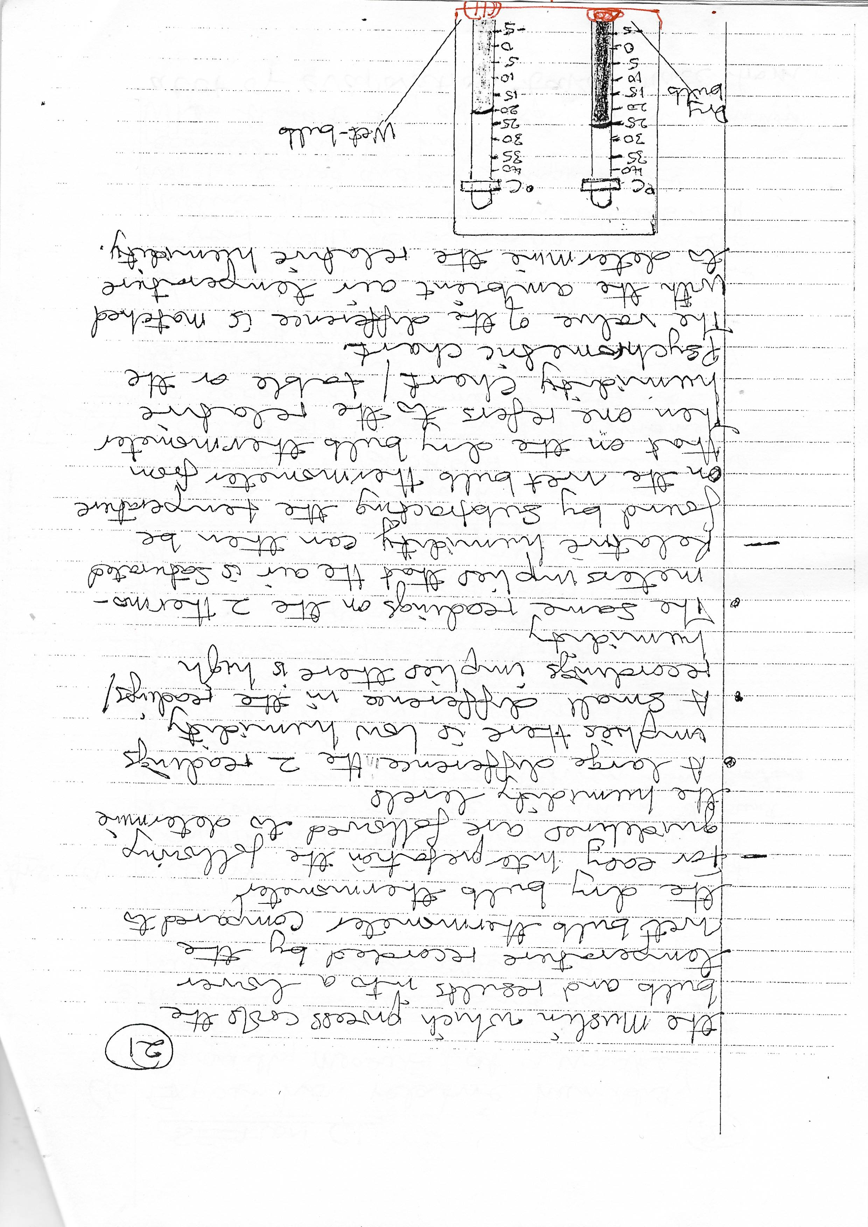

***Relative humidity chart / table***

|  |  |  |  |  |  |  |
| --- | --- | --- | --- | --- | --- | --- |
|  | *Difference between dry and wet bulb thermometer readings (oC)* | | | | | |
|  | *0* | *1* | *2* | *3* | *4* | *5* |
| *DRY BULB* | *%* | *%* | *%* | *%* | *%* | *%* |
| *22oC* | *100* | *90* | *82* | *73* | *65* | *60* |
| *24oC* | *100* | *91* | *82* | *74* | *66* | *62* |
| *26oC* | *100* | *91* | *83* | *75* | *67* | *64* |
| *28oC* | *100* | *91* | *83* | *76* | *68* | *65* |
| *30oC* | *100* | *92* | *84* | *77* | *68* | *66* |
| *32oC* | *100* | *92* | *85* | *78* | *70* | *68* |

*Impressional marking = 15 marks*

*(b) Account for the variations in the humidity levels experienced in a place.*

*(10 marks)*

* *Temperature – hotter conditions result into higher humidity than cool conditions*
* *Proximity to water bodies – places near water bodies experience higher humidity*
* *Nature and distribution of vegetation forested areas tend to have a higher humidity due to more transpiration*
* *Altitude / elevation – there tends to be more water vapour in low altitude as compared to high altitudes*
* *Ocean currents – warm ocean currents are associated with higher humidity on the adjacent coastal lands as compared to cold ocean currents*
* *Prevailing winds – areas influenced by moist winds have higher humidity levels*
* *Aspect – slopes in the direct path of sun’s rays tend to be warmer and consequently with high humidity levels*
* *Weather system like high – pressure and low pressure systems, frontal boundaries tropical cyclones etc can significantly impact of humidity levels*
* *Climate and seasonality – humidity levels often vary with different climates and seasons. Tropical climates have high humidity all year round wile arid /. Desert climates experience low humidity levels especially during hot days*
* *Human activities – like afforestation, deforestation, industrialization etc may influence the humidity levels of a place.*

*Impresional marking = 10 marks*

1. *(a)* ***Describe the characteristics of temperate forest vegetation in East Africa.***

*(10 marks)*

*Temperature forests in East Africa are also known as montane forests and are found in the highlands and adopted to high altitude / cool conditions. They may also be called alnine forests such forests are found in the Kenya highlands. The Rwenzoris and highlandas of Tanzania some of these temperate forests are planted forests e.g. Muko forest in Kabale.*

*The species are both coniferous and deciduous. The forests are characterized by the following.*

* *Species like podocamp, jumper, pines, cyresetc tend to be ever green*
* *They grow in pure stands*
* *They have tiny .*
* */ need shaped leaves*
* *They have straight trunks (boles)*
* *Branches tend to be short and curved upwards*
* *Most produce soft wood timber*
* *The coniferous species grow in a single layer*
* *Their roots tend to be fibrous in nature*
* *Dediduous species like the prunus Africana shed their leaves during the dry season to conserve moisture*
* *The deciduous montane forests have a amulti layered structured. The tall mature trees forma a dense, covering over head (canopy while the understory includes small trees, shrubs and herbaceous plants.*
* *They are characterized by growth of epiphytes such as orchids and ferns and mosses which tend to grow on tree trunks*

*Impressional marking = 10 marks*

*(b)* ***Account for the distribution of temperate forests in East Africa.***

*(15 marks)*

*Temperate / montane forests in East Africa are found in the Kenya highlands such as the Aberdare Mt. ranges, Mt. Kenya area, the Rwenzoris, Mt. Kilimanjaro, Mt. Meru and other highland areas or plateaus.*

*Factors that have influenced their distribution include the following:-*

* *High altitude of about 2500 – 300 metres above sea leel*
* *Heavy or moderate rainfall of more than 1500mm*
* *Cool conditions of less than 15o C*
* *Well drained soil conditions*
* *Shallow rocky soils especially of the hill or mountain sides*
* *Gently sloping hilly landscape to ensure good drainage*
* *Fairly acidic or neutral Ph conditions of the soil are required*
* *Government policy of gazetting montane forested areas as forest reserves or national parks has saved them from deforestation or extrinction*
* *Human activites of planting trees especially pines in several areas has also contributed to the distribution of temperate forests*
* *Historical factors like past climatic changes and geological events have also influenced distribution of temperate forests*

*Impressional marking = 15 marks*

1. *(a)* ***Account for the formation of Latosols.*** *(15 marks)*

*Landsols are zonal or lateritic soils formed in humid tropic regions. They tend to be reddish brown in colour, are freely draining, have an acid reaction and are rich in hydroxides of iron and alluminium or manganese*

*They result from deep weathering of rocks in tropical climates. The hot temepratures and heavy rainfall plus free drainage cause deep chemical weathering and rapid removal of silica and bases through leaching leaving a concentration of sequioxides of iron and alluninium (laterisation).*

*The parent rock material is often basaltic or other volcanic rocks rich in iron and alluminium compounds that tend to be resistant to weathering leading to their accumulation as others are leached away.*

*The continuous leaching process bbecasue of heavy rainfall leads to soil acidification and nutrient depletion.*

*The formation of latosols is a slow process that takes thousands to millions of years(time)*

*The texture of lotosols varies from clay to loamy sand*

*There are five (5) divisions of latosols namely:*

* *Weathered ferratlitic soils*
* *Ferrugenious soils*
* *Leached ferralitic soils*
* *Basisols*
* *Humiclatosols*

*Candidates for the formation of latosols include*

* *Heavy rainfall*
* *Hot temperatures*
* *Exposition of land surface by mars activities like deforestation*
* *Parent rocks rich in iron and alluminium*
* *Adequate time i.e. thousands of years*

*Impressional marking = 15 marks*

*(b)* ***Explain the economic significance of Laterite to the people of East Africa.***

*(10 marks)*

***Positive significance***

* *Used for brick making*
* *Use for resurfacing roads (murrum)*
* *Hardened laterite provides strong foundation for construction*
* *May result into possible deposits of Bauxite*
* *Laterite soils can be used for the growing of certain types of crops e.g. cassava, sweet potatoes*
* *Pineapples, oil palm, millet and cashew nuts.*

***Negative significance***

* *Lateritic soils lack a variety of plant nurients or are acidic in nature*
* *Low infiltration capacity hence encourages erosion*
* *It has hard and difficult to work hence hindering agricultural mechanization*
* *Laterite material results into slope instability and consequently slope collapse*
* *Laterite soils are generally coarse in texture and may hot retain adequate moisture for long.*

*5 x 1 = 5 marks*

*NB: Factual marking*

*Total = 25 marks*

# *END*